MACH4METAL

Metalworking machinery
Transito 21,
6909 DA BABBERICH
Netherlands
Tel. +31 (0)316 – 247123
Fax. +31 (0)316 - 247956
info@mach4metal.com
www.mach4metal.com

Account No: 66.52.13.883
IBAN : NL33 INGB 0665 2138 83
BIC : INGBNL2A

FEHLMANN PICOMAX 80 CNC
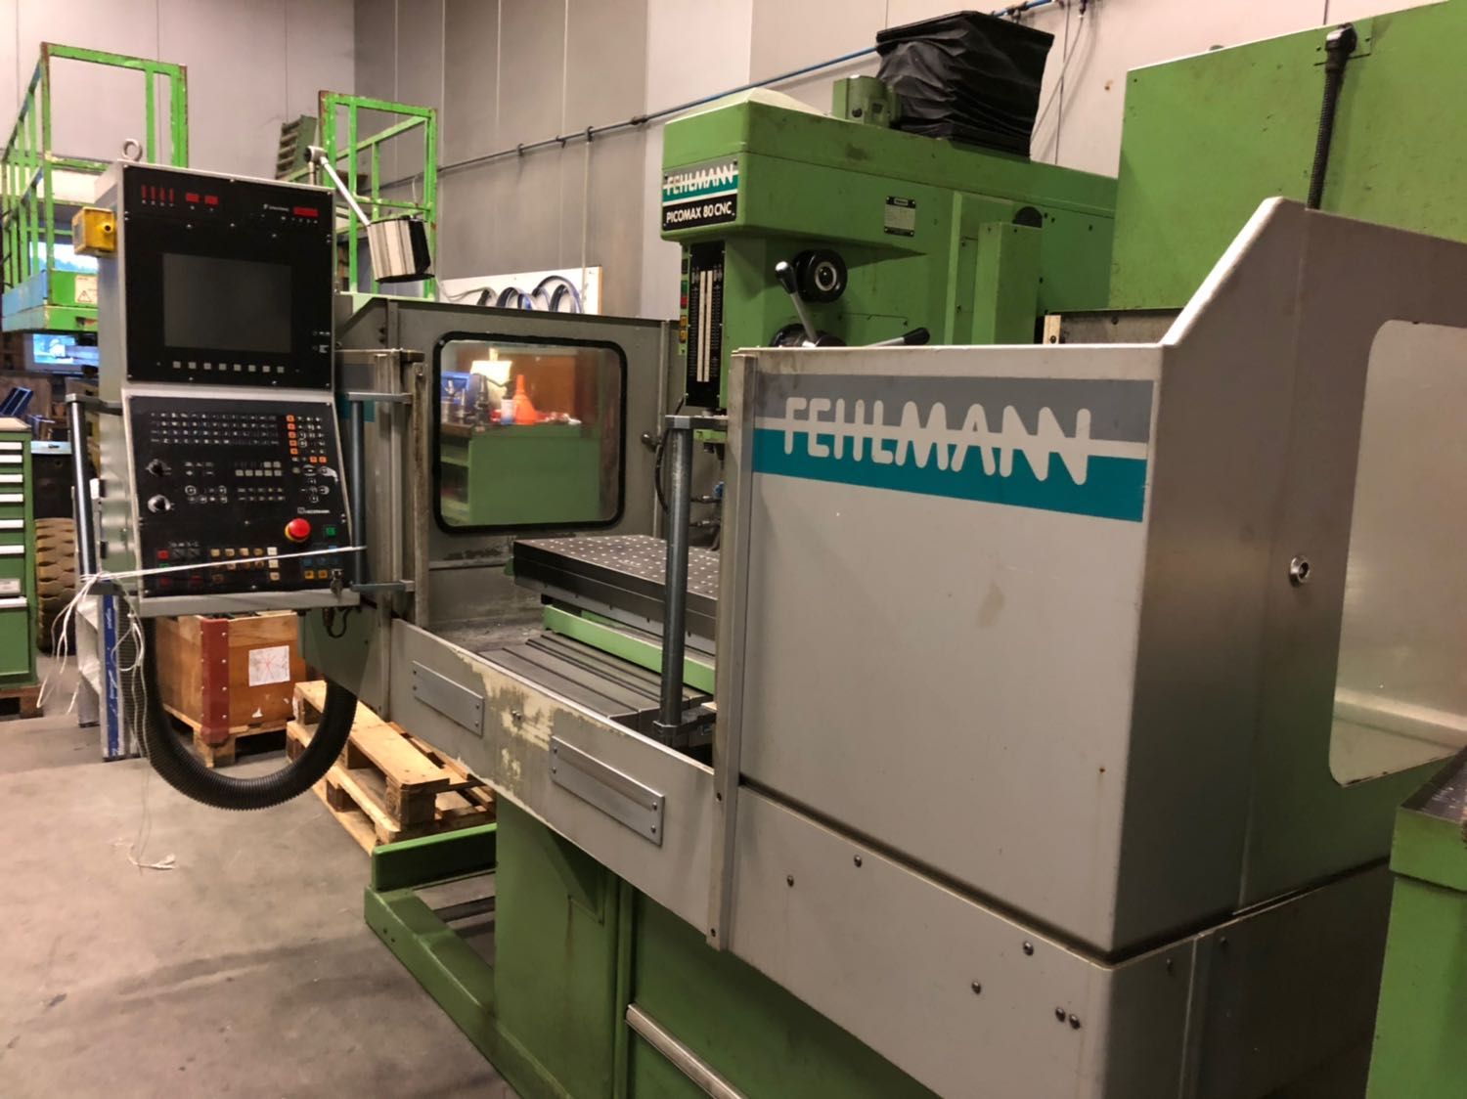

- Make : FEHLMANN SWISS
- Typ : PICOMAX 80 CNC 2/3
- No : 1519 3106
- Age : Nov 1992

- Capacity
- X travel : 700
- Y travel : 315
- Z travel : 180
- W travel : 495
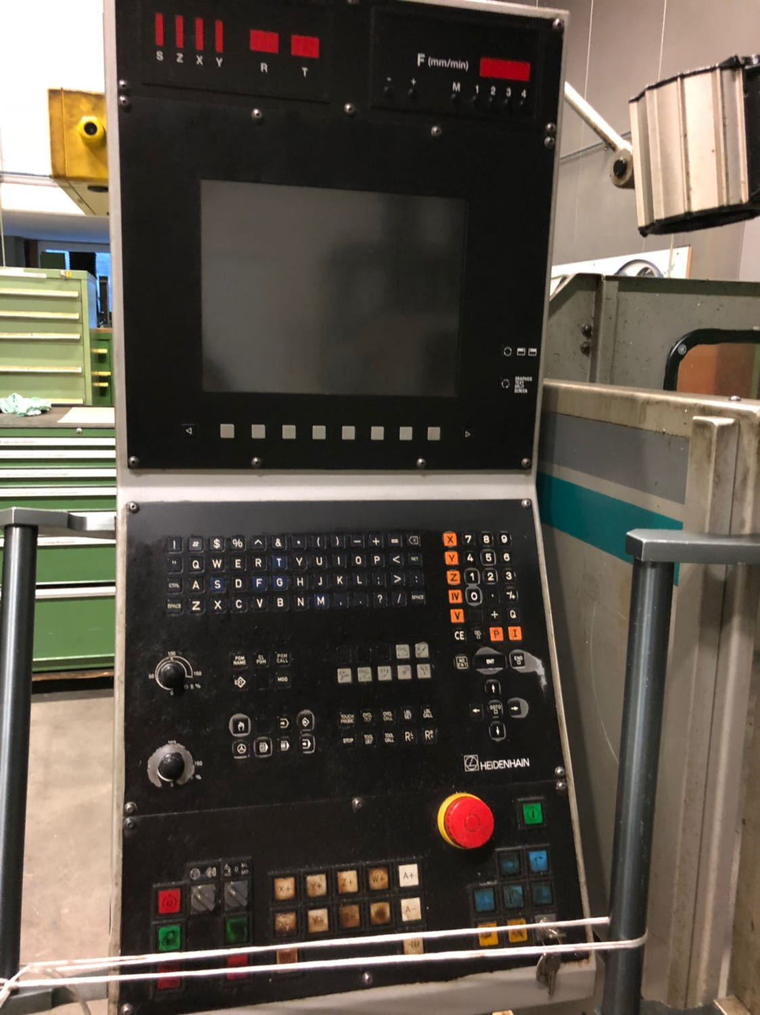

- Troth : 370
- Table length : 1230
- Table width : 410
- Table load : 250 Kg

- Spindle taper :
- Spindle speeds :
- Power :

- Rapid in X/Y : 9.000 mm/M
- Rapid in Z : 4.000 mm/M
- Rapid in w : 4.500 mm/M

- Dimensions
- Length : 2.150
- Width : 2.400
- Height : 2.220
- Weight : 3.000

- Heidenhain TNC 407 / 415

Please Note: The above information has been obtained to the best of our ability and belief from, and from the manufacturers where possible. It is given in good faith, but its accuracy can not be guaranteed. Accordingly, it will not form a representation or constitute contractual terms. We advise you to check any vital details!

